**План –конспект урока английского языка Клиновой Л.В.**

**Тема:** **Виды туризма. Говорение.**

**Класс:** 11

**Цель:** создание условий для совершенствования навыков аудирования и говорения для дальнейшего использования данной темы в межкультурном общении; формирования лексических навыков говорения.

**Задачи урока:**

Учебный аспект:

– отработка произносительных навыков;

–отработка своих предыдущих знаний как базу для понимания.

– тренировать учащихся в употреблении знакомых лексических выражений;

– способствовать формированию навыка говорения с применением изученного лексического материала;

– составление монологического высказывания по данной теме;

Развивающий аспект

–  развивать умение выделять главное, развивать мышление, развить слуховую память; развить слуховую реакцию;

– развивать способность к догадке;

– развивать умения строить высказывания  по данной теме;

– продолжать развивать умение общаться на иностранном языке.

Воспитательный аспект

– воспитывать умение работать в парах;

– воспитание взаимовыручки, помощи;

– воспитание умения слушать иноязычную речь и извлекать из нее необходимую информацию;

– повышение мотивации изучения иностранного языка.

**Ход урока**

**I. Организационный момент**:

Good morning I am glad to see you. Take your seats.

**II. Постановка целей и задач урока. Мотивация учебной деятельности.**

T.: First look at the board! Here you can see parts of three statements. Match them, read and try to guess what are we going to speak about?

1. The world is a book: if you don't travel, you read only one page. (Мир это книга: если ты не путешествуешь, ты читаешь только одну страницу.)
2. Sometimes one day spent in other places may give you more than ten years of living at home. (Иногда день, проведенный в других местах, может дать больше, чем десять лет жизни дома.)
3. Travelling helps to understand the beauty of the world and the value of time. (Путешествия помогают понять красоту мира и ценность времени.)

St.: We’ll speak about the travelling, tourism.

T.: You are right. Today we continue to speak about tourism, travelling and we’ll learn some types of tourism. We are going to listen to some texts and to do some exercises.

**III. Warming up. (Речевая зарядка)**

T: But first of all answer my questions:

***Do people like to travel? Why?***

***How can people travel?***

***What is your favourite means of travelling?***

***Why do people travel?***

***What is the farthest place you have visited?***

***Where would you go if you had a chance right now?***

**IV.** **Работа с текстом «Tourism. Types of tourism»**

***1)* *Pre-reading task (задание до работы с аудио-текстом)***

T: - You know that tourism is very popular now. And there are a lot of types of tourism today.

Maybe can you name any of them? …

Now look at the computer. We are going to watch a presentation “types of tourism” with some pictures that help you to understand meaning of some types of tourism. Please pay your attention on pronunciation.

***(Смотрим презентацию)***

Before we’ll listen to the text, look through the words from these texts.

**V. Phonetic exercises. (Фонетическая зарядка)**

Student Exchange Program [ˈstjuːdnt ɪksˈtʃeɪndʒ ˈprəʊɡræm ]

battlefield [ˈbætl̩fiːld]

environment [ ɪnˈvaɪrənmənt ]

spa [ spɑː ]

to involve [ ɪnˈvɒlv ]

cemetery [ ˈsemətri ]

implementation [ ɪmplɪmenˈteɪʃn ]

untouched [ ʌnˈtʌtʃt ]

energy efficiency [ ˈenədʒi  ɪˈfɪʃənsi]

water conservation [ ˈwɔːtə ˌkɒnseˈveɪʃən]

heritage tourism [ˈherɪtɪdʒ ˈtʊərɪzəm ]

to be featured in [ ˈfiː.tʃəd]

educational tourism  [ˌedjʊˈkeɪʃənəl ˈtʊərɪzəm]

military tourism[ ˈmɪlətri ˈtʊərɪzəm]

ecotourism[ ˈiːkəʊˌtʊərɪzəm ]

to treat [ triːt ]

health-giving [ helθ- ɡɪvɪŋ  ]

fragile [ ˈfrædʒaɪl ]

low-impact travel  [ ləʊ-ˈɪmpækt ˈtrævl]

destination  [ ˌdestɪˈneɪʃən ]

relevance [ ˈreləvəns ]

combat aircraft [ ˈkɒm.bætˈeəkrɑːft ]

**VI*.* a) Listen to the text about six types of tourism. Place the types of tourism in the order of being defined by the speaker.**

1. 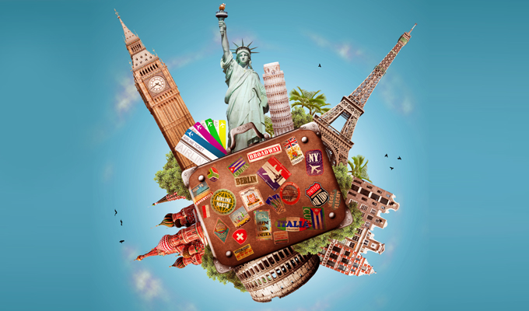pop culture tourism **____**
2. educational tourism ____
3. eco tourism ____
4. health tourism ____
5. ethno tourism ___
6. military tourism _____

There is a code on the board, check yourself **C-B-E-D-F-A**

**### Физминутка (с речевой зарядкой**) ####

**Come to me and take a card, read and name what type of tourism is this**.

(There is a place, your task is to name the type of tourism)

|  |  |
| --- | --- |
| 1. Visiting the Great Barrier Reef or the National Park Belovezhskaya Pushcha. (e) 2. Going to Africa to give food to the children. (b) 3. Flying to China to learn Chinese. (f) 4. Visiting Australia to surf the big waves. (c) 5. Travelling to Paris, then leaving for Amsterdam, then visiting London and Cardiff. (h) 6. Going to Donbass to see military actions in live. (a) 7. Spending summer at the Black Sea. (e) 8. Walking along the Great Canyon in America with good friends and a big rucksack on your back.(g) | 1. War tourism. 2. Voluntourism. 3. Adventure tourism. 4. Eco tourism. 5. Health tourism 6. Educational tourism. 7. Backpacking. 8. International tourism. |

**VI. b) Some of the sentences in the following definitions are mixed. Listen to the text and restore the definitions of the types of tourism.**

- volunteer work and the promotion of recycling, energy efficiency and water conservation.

- with an interest in current or historical military sites and facilities, including museums, battlefields, cemeteries and technology.

- to acquire new knowledge and experiences that meet the intellectual needs and individual growth of the traveler.

- It can also include participation in a country’s rituals or festivals.

|  |  |  |
| --- | --- | --- |
| **A type of tourism** | **Definition** | **A place of destination** |
|  | As part of the green movement, this kind of tourism is defined as a responsible, low-impact travel to fragile, untouched and protected areas. This type of domestic and international tourism involves ______________________________. While having a rest tourists should behave in environmentally friendly way. |  |
|  | This kind of tourism can be called heritage tourism. It involves immersion in society's lifestyle, its people's history, its art and architecture, its religion, and any other elements that have shaped it and its people. __________ |  |
|  | This kind of tourism includes a journey to specific destinations that offer cultural attractions, including historic sites and artistic and cultural events and shows. The aim is _____________________________________. |  |
|  | This term is used to describe the idea of recreational travel to war zones and the places of military-historical relevance. It is for those ____________________________________  ____________________.The tourists can take part in different activities such as shooting, riding a tank or flying combat aircraft. |  |

**VI. c) Match the place of destination with the suitable type of tourism**.

- **The “Braslav Lakes” National Park**

**- The Museum of Old Crafts “Dudutki”**

**- The Mir Castle Complex**

**- The Historical and Cultural Complex “Stalin’s Line”**

**VII. And now you are going to work in pairs.** Choose one of the places from the list and give us short information about this destination according to the plan using the text.

**Plan**

1. Place of destination

2. Type of tourism

3. Type of travelling

4. Some information about this place

**The Museum of Old Crafts “Dudutki”**

The open-air museum “Dudutki” created in 1995 with its artifacts of folk crafts and workshops of the XIX century.

Here you cane*njoy a fascinating journey into the world of old-time daily life and crafts, visit workrooms, a bakery and a brewery, an operating windmill, a zoological garden.*

You can *taste freshly baked bread, homemade cheese and local drinks.*

You can see the only working mill in Belarus, visit pottery, forge of vintage cars… You will *enjoy riding in the hackney-cabs, visit the meadow of picnics, and feel the atmosphere of old estate.*

Here you can *buy wonderful souvenirs* and *take pictures.*

an artifact [ˈɑːtɪfækt]

a fascinating journey [ ˈfæsɪneɪtɪŋ ˈdʒɜːni]

a brewery [ ˈbrʊəri ]

a windmill [ ˈwɪndmɪl]

a pottery [ ˈpɒtəri ]

to forge of vintage cars [ fɔːdʒ əv ˈvɪntɪdʒ kɑːrs]

a hackney-cab [ ˈhæknɪ kæb]

a meadow  [ ˈmedəʊ ]

an estate [ ɪˈsteɪt ]

**The Historical and Cultural Complex “Stalin’s Line”**

The Historical and Cultural Complex “Stalin’s Line” was opened in 2005 in memory of the defenders of Minsk.

The territory of Stalin’s Line is about 30 hectares in size.

*There is a wide range of the military equipment of the war and the post-war period - aircraft, armoured vehicles, artillery.*

"Stalin's line" attracts both experts in the sphere of military equipments, and ordinary tourists. The first deepen the knowledge, and the second receive unforgettable impressions.

You *can try some soldier porridge, take part in different activities such as shooting, riding in rare tanks*.

Here you can *buy wonderful souvenirs* and *take pictures.*

a defender [ dɪˈfendər ]

a hectare [ ˈhekteər ]

an aircraft  [ˈeəkrɑːft ]

an armoured vehicle [ ˈɑːməd  ˈviːəkl ]

an artillery [ ɑːˈtɪləri ]

to deepen [ ˈdiːpən ]

**The “Braslav Lakes” National Park**

The national park was set up in September 1995. It is a unique ecosystem with a number of lakes and a large area of pine forests.

The major pride of the region is its lakes. Here you can find about 30 lakes of various sizes, forms, depth, composition, fauna and flora. For their unusual beauty they are called “the blue necklace”.

Hikers and backpackers c*an go for a walk along ecopath Belmont Park or take a cruise tour on lakes.*

Tourist *can enjoy beautiful nature, breath fresh air, listen to the bird’s songs and learn about the rare species of animals, birds and fish listed in the Belarusian Red Book.*

Here you can *take picturesque pictures.*

a pride [ praɪd ]

a depth [ depθ ]

a composition [ ˌkɒmpəˈzɪʃən ]

a fauna [ ˈfɔːnə ]

a necklace [ˈnekləs]

a hiker [ˈhaɪkə ]

a backpacker [ˈbækpækə]

an ecopath [ iːkəʊ pɑːθ ]

a cruise tour [ kruːz tʊə ]

**The Mir Castle Complex**

Mir Castle in Grodno region is one of the most important tourist attractions in Belarus, an outstanding 16th-century fortification and a UNESCO World Heritage site.

The successful blend of Gothic, Baroque and Renaissance architecture makes Mir Castle one of the most impressive castles in Europe.

Mir complex includes a castle ramparts, English landscape park, Italian garden reconstruction, pond, outbuilding, church-tomb Svyatopolk-Mirsky, guard's house and a roadside chapel.

You can *see unique pieces of furniture, weapons, tapestries and others at the museums*.

You can *enjoy the time being there and learning the history of Mir Castle.*

You can *visit a restaurant with dishes of the old kitchen and a souvenir shop with products of Belarusian artists and buy some souvenirs.*

Here you can *take picturesque pictures.*

a fortification [ ˌfɔːtɪfɪˈkeɪʃən ]

a site [ saɪt ]

a blend [ blend ]

a Gothic, Baroque and Renaissance architecture [ ˈɡɒθɪk bəˈrɒk  rəˈneɪsəns ˈɑːkɪtektʃə ]

a castle rampart [ ˈkɑːsl ˈræmpɑːt ] *вал*

a pond  [ pɒnd ]

an outbuilding  [ ˈaʊtˌbɪl.dɪŋ ]  *надворная постройка*

a church-tomb  [ tʃɜːtʃ  tuːm ]*церковная гробница*

guard's house [ ɡɑːdz haʊs ]

a roadside chapel [ ˈrəʊdsaɪd ˈtʃæp.əl]

a tapestry [ ˈtæpɪstri ] гобелен

**VIII. Your home task is to write the story about the ideal tour using this plan.**





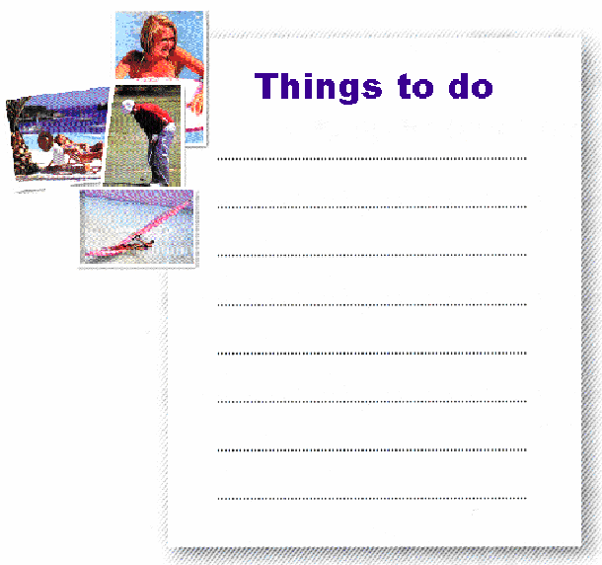

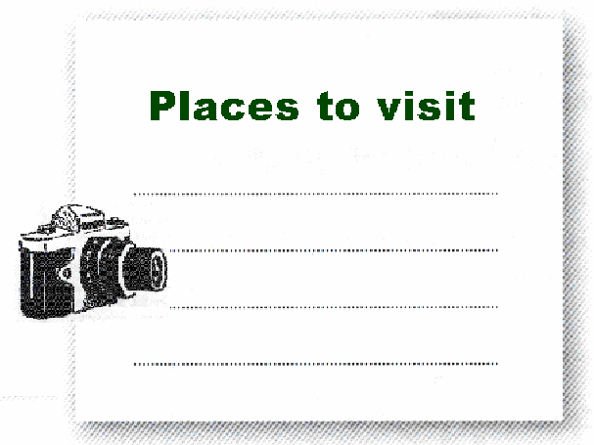

**IX. Рефлексия**

We’ve learned some information about tourism today. Please answer the questions.

* + What is tourism?
  + Why do people travel? Give a few reasons!
  + And what types of tourism have you learned?
  + What type of tourism is suitable for you? Why?

**X. Подведение итогов занятия и объявление домашнего задания.**

As you see, tourism has grown very much, mostly because people’s lifestyles have changed. Today we’ve learned some information about types of tourism. And, I think this information will be useful for you.

Thanks for your job. Your answers were excellent. The lesson is over.

* + What is tourism?
  + Why do people travel? Give a few reasons!
  + And what types of tourism have you learned?
  + What type of tourism is suitable for you? Why?

1. **Tourism** is [travel](https://en.wikipedia.org/wiki/Travel) for pleasure or business
2. People travel for many different reasons – **to have fun, visit other countries and learn about other cultures, or just relax from stressful working life.**

Millions of people all over the world spend their holidays travelling. **They travel to see other countries and continents, modern cities and the ruins of ancient towns, they travel to enjoy picturesque places, or just for a change of scene.**

Modern life is impossible without travelling. **Thousands of people travel every day either on business or for pleasure.**

1. **There are a lot of types of tourism….**
2. **I think that ecotourism is suitable for me because I like nature.**